# Windows – Eclipse IDE Installation

1. Start the Eclipse IDE installation by extracting the archive and executing the installer file. On executing eclipse-inst-jre-win64.exe application file, the following window pops-up:

Figure 11: Selecting the Eclipse IDE for Embedded C/C++ developers

1. Clicking on Eclipse IDE for Embedded C/C++ developers redirects to the installation window.

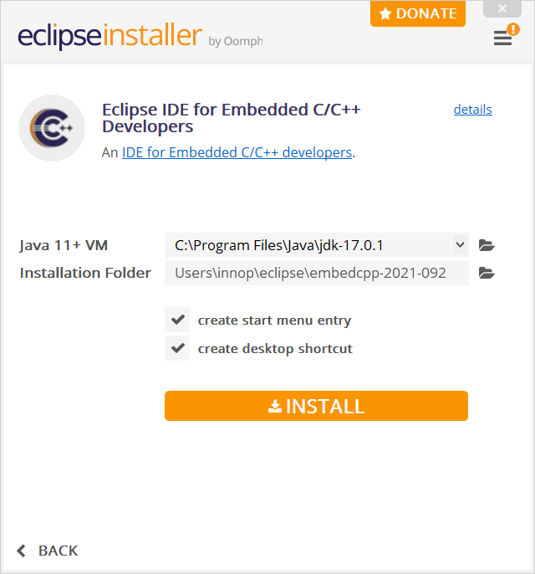

Figure 12: Installation of Eclipse IDE for Embedded C/C++ developers

1. The installer takes the default JDK path of the user’s machine as Eclipse uses externally installed JDKs to run itself. Select the installation folder for eclipse and click INSTALL.

Figure 13: Eclipse IDE for Embedded C/C++ developers launch window

1. After completing the installation, the Eclipse installer prompts for permission to launch. Click on LAUNCH.